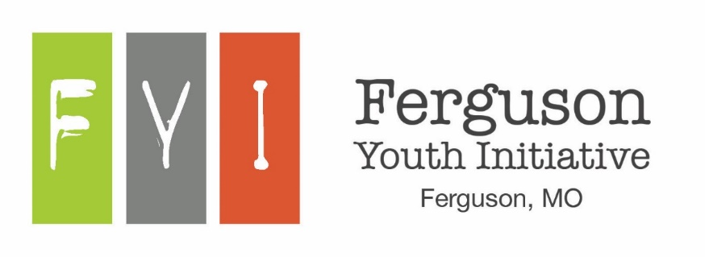

Prospective Board Member Application
The Ferguson Youth Initiative (FYI) is a 501(c)3 nonprofit serving the youth of the Ferguson community by encouraging them and engaging them as active members of the community, developing programs as needed, and further communicating and partnering with existing community youth programs.
The purpose of this application is to enable the current FYI Non-Profit Board to make appropriate choices of Board Members for service to FYI, the Ferguson Youth Advisory Board, and the young people of the Ferguson Community.
Applicants interested in serving as a board member should first read and understand the expectations and rules of Board Membership, read and understand the By-Laws, and submit a completed application before April 30, 2017. Applicants may also submit references or letters of recommendation for consideration if they so choose. All correspondence should be sent to FYI, 106 Church Street, Ferguson, MO 63135.
Ferguson Youth Initiative Board of Director Expectations:

Support the Mission Statement of FYI.
Actively engage and recruit youth to participate in FYI. Work as a part of a cohesive team with common goals. Share his/her skills and expertise.
Dedicate time to FYI and FYAB board meetings. Respect and support the majority decisions of the Board.
Volunteer and assist in FYI’s youth engagement programs and activities, including fundraising efforts Participate actively in Board meetings, actions, fundraisers and public events.
Have no more than three (3) consecutive unexcused absences from board meetings and/or activities. Represent all those whom this organization serves and not a particular geographic area or interest group. Remain aware of the activities that are planned and make yourself available to participate.
Declare conflicts of interest as it pertains to your position on the Board and abstain from voting when appropriate.
- Do your best to ensure that the Ferguson Youth Initiative is well-maintained, financially secure, growing and always operating in the best interest of the youth.
- Board Members will be solicited for a cash or an in-kind donation 100% participation is sought
Ferguson Youth Initiative Board of Director Rules:

There will be no criticizing of fellow Board members or their opinions in or out of the Board meetings. There will be no use of the organization for personal advantage or that of friends or relatives.
There will be no discussion of the confidential proceedings of the Board outside the Board room.

If you are accepted as a FYI Board Member, you will be required to obtain and submit records of a full criminal background check.

Date: Information:
- Candidate Name:
First Middle Last

Mailing Address: City: State: Zip:
Home Phone: Email:

- Current Position: Current Employer: Work Phone:
- Relevant Experience and/or Employment: Please attach resume.

- Please circle area(s) of expertise/contribution you feel you can make to further the mission of FYI:

Youth Outreach / Advocacy Nonprofit Experience Youth Programs / Events
Personnel / Human Resources Community Service
Policy Development
Public Relations

Other

Fundraising Service Learning

Program Evaluation
Social Media / Communications
Other

Strategic Planning Education / Instruction

Graphic Design / Technology
Grant writing
Other

Finance /Accounting Fundraising

- Please list boards and committees that you serve on, or have served on (business, civic, community, fraternal, political, professional, recreational, religious, and social).
Organization Role/Title Dates of Service

- What other volunteer commitments do you currently have?

- What experience do you have working with youth, specifically between the ages of 13 and 19?

- Why are you interested in serving as a Board member for FYI?

- How do you feel FYI would benefit from your involvement on the Board?

- Please list any groups, organizations or businesses that you could serve as a liaison on behalf of FYI:

- Please share any other information you feel important for consideration of your application to serve as a FYI Board member:

  - Are you aware of any information about yourself, which might tend to reflect unfavorably on your reputation, morals, character or ability as a board member for FYI?
Yes No if yes and would like to explain, use a separate sheet of paper.

  - Have you ever been convicted of a felony?

Yes No if yes and would like to explain, use a separate sheet of paper.

  - Have you ever been convicted of a controlled substance offense?

Yes No if yes and would like to explain, use a separate sheet of paper.

  - Have you ever been convicted of a sex-related crime?

Yes No if yes and would like to explain, use a separate sheet of paper.

- Supplement Questions:

  - Are you willing and able to attend board meetings? Yes No

  - Are you willing to interact with parents, children, and fellow board members

with professionalism and respect? Yes No

  - Are you willing to uphold the responsibilities assigned to you? Yes No

By signing below, I attest that the information I have provided is true and correct. Additionally, my signature represents my agreement to the following statements: I understand and agree to the Ferguson Youth Initiative Board of Directors Expectations; I agree to participate pursuant to the Policies, Procedures and Bylaws of the Ferguson Youth Initiative Board; and I understand that if conflicts prevent me from performing the rules and expectations as a Board Member, I may be removed from the Board by a majority vote.
Signature: Date:

Thank you very much for applying.

For Board Use

Nominee has had a personal meeting with an existing Board Member. Who/Date?
Nominee reviewed by the committee. Date?
Nominee proposed to the Board. Date?
Board action: Elected Rejected Date?

